Thank you for your interest in CSF’s Spring Grant Cycle. This year we mark 35 years of distributing approximately $200,000 to over 200 groups and individuals - for the empowerment and betterment of our communities. These local grant dollars come from donations and Rounding Up at the Olympia Food Co-op. We look forward to the opportunity to support your application - and our collective potential!

How to Apply
- Read this Cover Sheet & fill out the Grant Application (below) in its entirety
- Submit Grant Application via thurstoncsf@comcast.net
- Email submissions strongly preferred but paper applications accepted when mailed to 2103 Harrison Ave NW #2715 Olympia WA 98502 by the deadline noted below

Important Dates & Details
Funding Amounts: Applicants may request up to $1,500. CSF’s funding pool is limited. Please request funding for only what you need. This ensures dollars are spread for greater positive impact in our communities.
March 19: Grant Round Opens
April 24: Grant Applications Due (accepted up to 11:59 pm)
May 4: In-person Grant Applicant Interviews (approx. 9am-1pm)

- We are now back to in-person interviews but can revert to Zoom interviews if health conditions intervene.
- Applicants that meet CSF’s minimum criteria are scheduled for 15-minute interviews on May 4. Please ensure that at least one representative from your project is able to attend the interview as the verbal interview is an integral part of our decision-making process.
- Final consensus-based funding decisions are made following grant interviews, and award checks are distributed soon thereafter. All applicants will be notified of either award or denial of funds.
- CSF requires all funded projects to fill out a Grant Completion Report within 30 days following the end of the project.
- Please note CSF policy allows previous grantees to apply again, with two conditions: 1) it must be at least one year since receipt of a prior grant award, and 2) applicant must have filed a Grant Completion Report from any previous grant project.

Please reach out thurstoncsf@comcast.net with any questions!

General Grant Criteria
The CSF, a Washington state registered non-profit corporation, provides grant funding for progressive, community-oriented projects across all of Thurston County. Grants are awarded for organizational needs such as but not limited to start-up funding, public outreach, training, equipment, and special projects. CSF realizes that most applicants will neither be involved in all these activities, nor fit all the criteria listed below. Hence, the CSF treats all applications as case-specific and unique.

CSF considers applications which:
- Are developed and led by residents of Thurston County within the County
- Operate in a democratic, nondiscriminatory manner which is responsive to the constituency served
- Actively pursue cultural diversity in group composition
- Actively work toward a more just and equitable world of ecological and economic balance and personal and social responsibility

CSF will generally not fund:
- Direct social service projects that are, or can be, funded by traditional funding sources (i.e., government agencies, United Way, major foundations, etc.)
- One-time artistic or cultural events that do NOT include community organizing or development as part of the work
- Ongoing organizational operating costs. You can request one-time operating (bridge) funding— see the question in the budget section of the application below

CSF seeks to fund groups working in the following areas:
Social Justice  (people >> people) | Racial Equity, Youth, LGBTQIA, Domestic Violence, Native Peoples, Elderly, Parenting & Child Care, Civil Liberties, Disarmament, Foreign Affairs
Community Building  (people >> society) | Education, Economics, Communication, Arts & Culture, Health Care, Transportation, Housing & Homelessness, Grassroots Democracy, Unemployed, Underemployed & Working Poor, Labor Issues, Spirituality, Sustainability
Environment  (society >> environment) | Environmental Defense, Agriculture, Animal Rights, Land Use Planning, Forestry, Energy, Water Quality, Waste & Recycling, Environmental Racism, Endangered Species

CSF is most interested in those groups that express the following:
Values  - Material simplicity  - Participatory democracy  - Community-oriented economics  - Ecologically conscientious society  - Nonviolent forms of conflict resolution  - Respect for human dignity and diversity  - Connect local activities with broader social change issues  - Inclusive of people with varying political, social, and cultural backgrounds  Strategies and Activities  - Work to introduce new people to ideas of social change  - Organize people to participate in social change activities  - Promote cultural and artistic activities that encourage social change | Organizational Approach  - Encourage collaboration with other social change groups  - Effectively reach and build an organization responsive to the community  - Work to make power relationships equitable within their group and issue area  Long Term Goals  - Develop and implement long-range strategies and goals  - Advance a self-sustaining financial plan based on realistic sources of revenue  - Pass on skills and expertise to increase the body of local and regional organizers

Please Know the Community Sustaining Fund Board
Welcomes Additional Participation Support
From Our Extended Community
For more information about us:
http://oly-wa.us/csf/index.php
Facebook

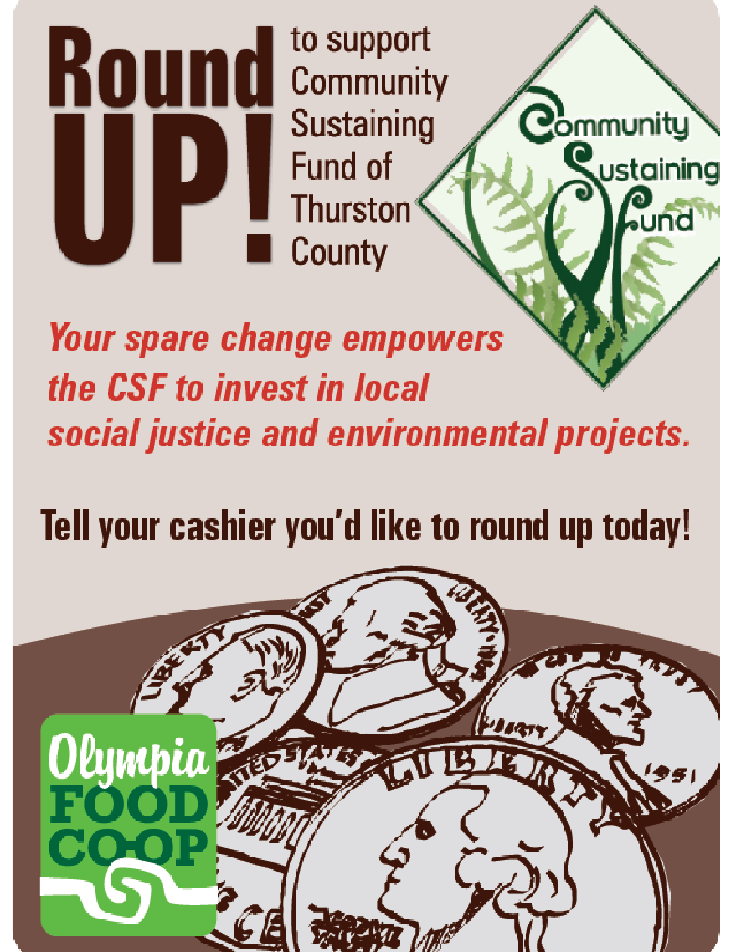
We gratefully accept donations through the PayPal icon via the home page of our website

Please Remember To “Round-Up” Your Purchases While shopping at either
the Westside or Eastside
Olympia Food Co-Ops

https://olympiafood.coop/

Community Sustaining Fund of Thurston County

Grant Application
Please attempt to confine your answers to the available space, and
send completed application via email file attachment to: thurstoncsf@comcast.net

PART 1: GENERAL INFORMATION
Project Title ____________________________________________________________
Group or Individual Name __________________________________________________
Email _______________________________ Address ___________________________
Project Coordinator ___________________ Phone (w) ___________ (cell) ____________
Email _______________________________ Address ___________________________
Alternate Contact _____________________Phone (w) ___________ (cell) ____________
Organizational Status:
__ Tax-exempt Organization __ Unincorporated Group
__ Individual __ For-Profit Business

Previous CSF Grant Recipient? If yes, when? ____

Total Amount Requested from CSF $____________

Project Dates: Begin __________ End ___________

Federal ID Number of Group (if applicable): ____________________________________
CSF would like to have the ability to share this application with local community groups involved with the issues it addresses. If you would prefer to keep this application confidential, please indicate here ______.

Project Coordinator Signature Date
How did you hear about our organization?
__ Co-op __ Word-of-Mouth
__ Internet __ Other? _______________________________

PART 2: INTRODUCTION – APPLICANT
- Please provide a brief description of your group, or a history of related activities if an individual applicant.
- Describe your project (when it started, what you want funded, community need, etc.)

PART 3: FINANCIAL INFORMATION
- Please fill out this budget matrix completely.
Budget Item | Priority:  high, medium or low | Requested from CSF | Total Budget for Project
Stipends
Office Supplies
Postage
Printing/Copying
Phone
Equipment
Other
1.
2.
Totals:
Total Organizational Budget for Current Year:

- Any Additional Budget Information?

- If you are requesting one-time operational/bridge funding, please answer these additional questions:
  - What factors have influenced your decision to seek grant funding for operations?

  - What have you done or are doing to solidify the financial sustainability of your organization or project?

  - How critical is your need for operational dollars and what would happen if you do not get them?

PART 4: PROJECT INFORMATION
- How does your project directly relate to CSF funding criteria?

- How will you accomplish your project? (include specific activities and timelines)

- How will you determine if your project is working and whether its goals were accomplished?

- In what ways will you let the greater community know about your project outcomes and those funding the project?

- Will you assist / support CSF in mutually supportive outreach activities?

PART 5: ORGANIZATION/GROUP INFORMATION
- CSF is committed to supporting those that include social/racial equity goals in their social change work. Describe your group’s present composition.
- Do you interact with others working on similar issues? If so, who? Describe how you will work with other individuals and groups.
- List name and contact information (email or telephone) of two references familiar with your work, but not a part of your group, nor board members of CSF.
- Please add anything that will help us better understand your group and/or this project. If you attach any information to the application, please list here.
note: submissions and attachments will not be returned.

thank you for completing this application Rev. 9.22

in order to enable greater community collaboration, would you like to have
your contact information shared with others?
YES ___________ NO _____________

